**Ideas for Puzzles**

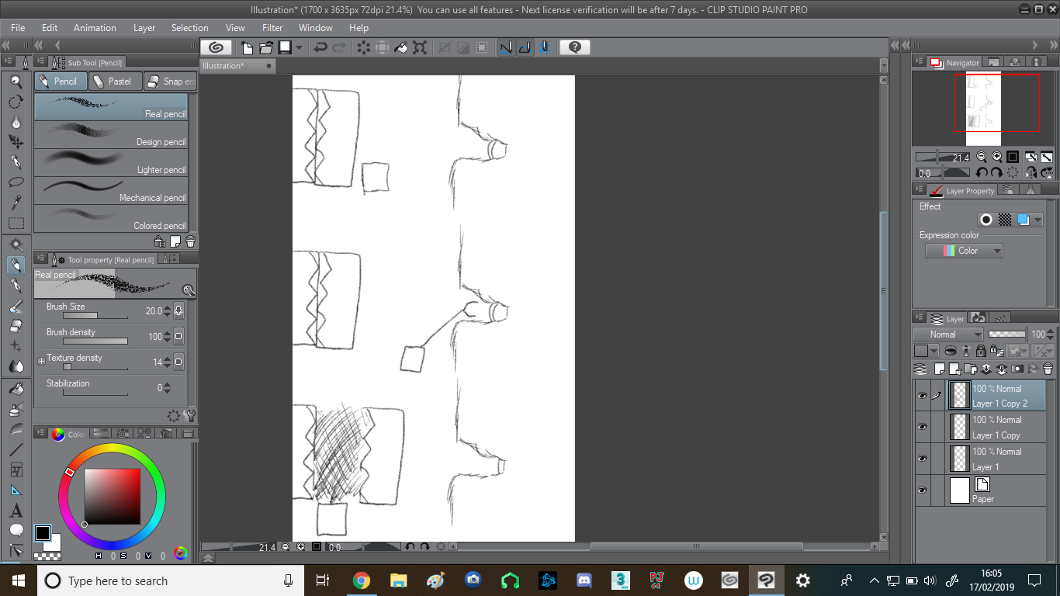How the player interacts with the environment of the game is crucial to the game’s success and enjoyability. In this document I will draft some ideas as to how the player can be made to use the mechanics of the game to help progress in the game world.

Figure : A switch in a nook only accessible by using the grappling hook.

In Figure 1, the player (represented by the box) encounters a locked door. There is a button in the wall (a bright colour compared to the rest of the environment so it stands out) inside a nook the player cannot fit into.

They must use their grappling hook to press the button, which opens the locked door. This a straightforward concept that demonstrates to the player that their grappling hook can be used for more than just jumping, and encourages further experimentation.

This type of puzzle can be multiplied-the player would have to hit multiple switches in the correct order, for example, or must press certain switches in order to escape a sequence of doors.

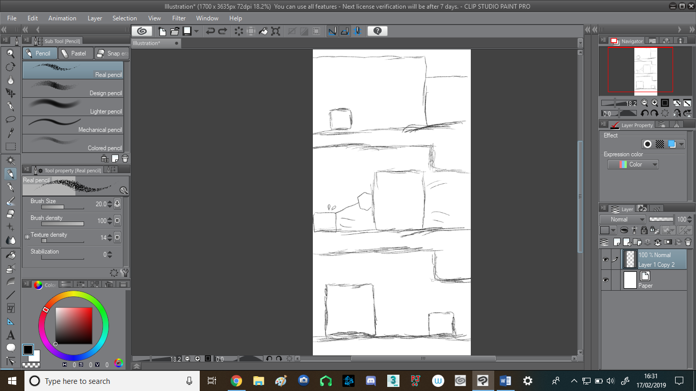

In Figure 2, the player has reached a dead end as the only way to progress is blocked off. However, using environmental clues (part of the wall being a different colour from the rest of the tunnel) and drag marks on the ground, the player will try and grapple the odd part of the wall and discover that it is an object that can be pulled.

For the player’s sake all objects that can be dragged this way should be the same colour or very similar, so that if the player is stuck they can try remembering what can be pulled and what can’t much more easily.  
  
There should be a way to reset these types of puzzles so that the player does not get stuck or trapped while trying to solve them. Perhaps these objects could be pulled into pits in the floor so that they are  
permanently out of the way once the puzzle has been solved?

Figure : The player can use their grappling hook for dragging around certain objects.

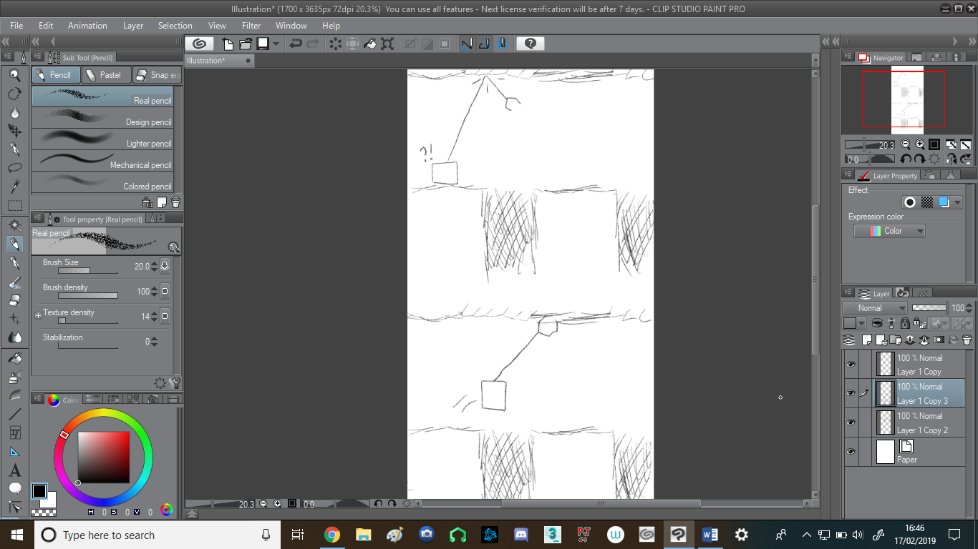In Figure 3, the player must cross gaps by grappling onto the ceiling. However, certain parts of the ceiling (ice? Rubber?) cannot be grappled, so the player has to get more precise grappling angles to traverse the area.

Figure : Certain parts of ceilings and walls cannot be grappled.

This could make for some “falling” puzzles where the player has to go down the right path to progress and cannot just grapple themselves back up to the top should they pick the wrong path.

This could also be used to make getting around enemies more difficult; the player would have to make use of their crouching ability or the terrain in order to sneak under enemies instead of going over them.